Feedback code:
def feedback_write():
feedback = input("Enter your feedback:")
good=["good","great","awesome","excellent"]
bad=["bad","worst","poor","terrible","horrible"]
try:
if any(word in feedback.lower() for word in good):
with open("good_feedback.txt","a") as file:
file.write(feedback +"\n")
elif any(word in feedback.lower() for word in bad):
with open("bad_feedback.txt","a") as file:
file.write(feedback +"\n")
else:
with open("neutral_feedback.txt","a") as file:
file.write(feedback +"\n")
except Exception as e:
print("An error occurred while saving your feedback")
else:
print("Thank you for your feedback")
finally:
print("Feedbak submission process completed")

def read_feedback():
try:
with open("good_feedback.txt","r") as file:
good_feedback = file.readlines()
with open("bad_feedback.txt","r") as file:
bad_feedback = file.readlines()
with open("neutral_feedback.txt","r") as file:
neutral_feedback = file.readlines()

print("Good feedback:")
for line in good_feedback:
print(line.strip())
print("Bad feedback:")
for line in bad_feedback:
print(line.strip())
print("Neutral feedback:")
for line in neutral_feedback:
print(line.strip())

except FileNotFoundError:
print("No feedback file found")
except Exception as e:
print("An error occurred while reading")
else:
print("Feedback reading process completed")
finally:
print("Thank you for your feedback")
print("Code run successfully")

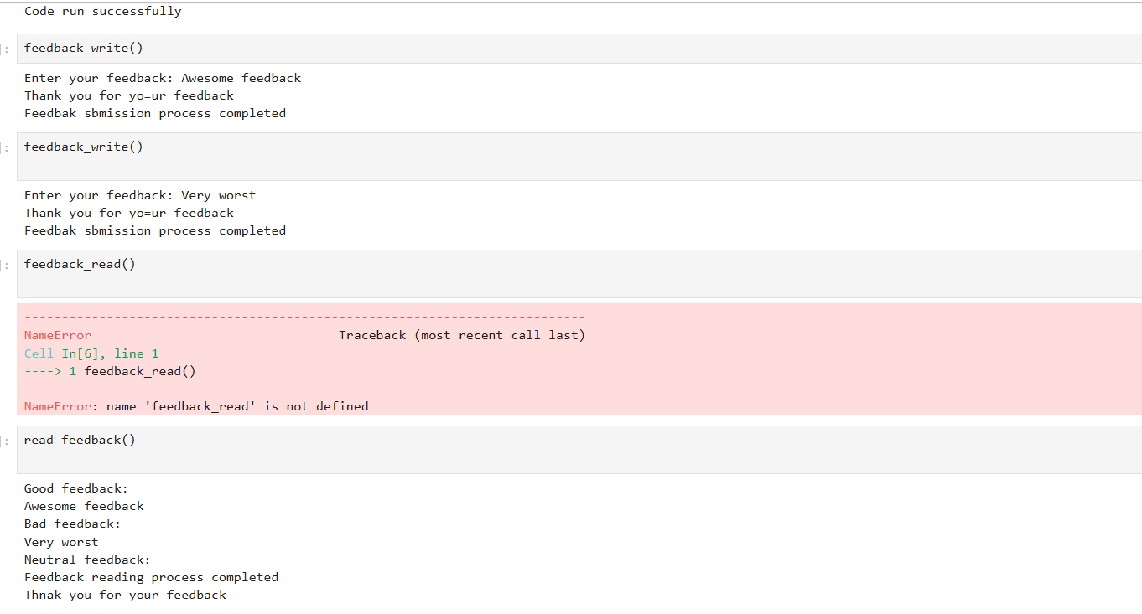
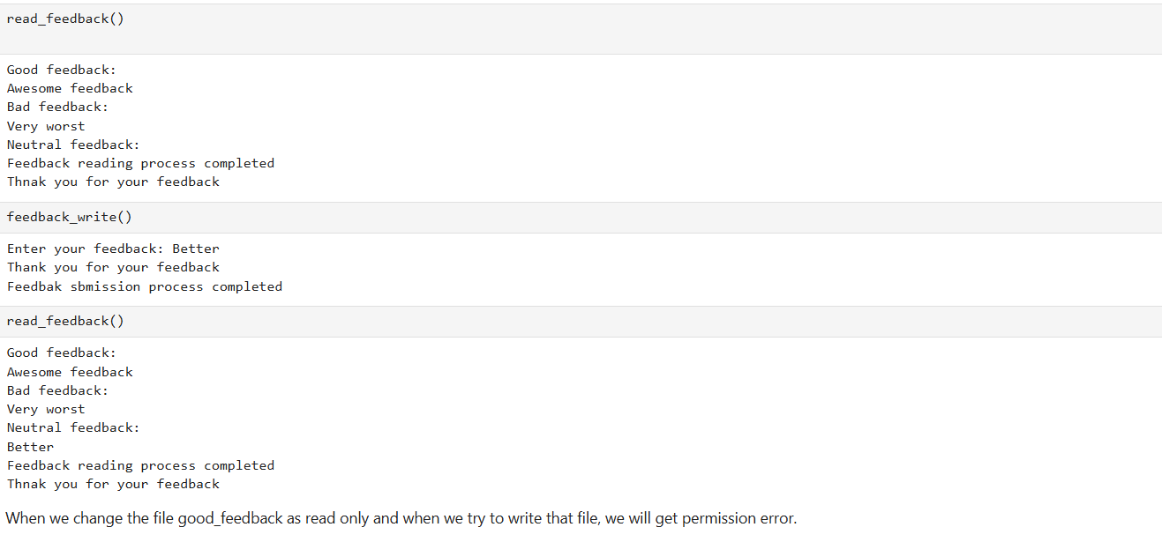

In Feedback Management System, exception handling is used to make the program more reliable and user-friendly by catching errors and ensuring the program doesn’t crash unexpectedly.
I Have used try, except, else and finally blocks.

